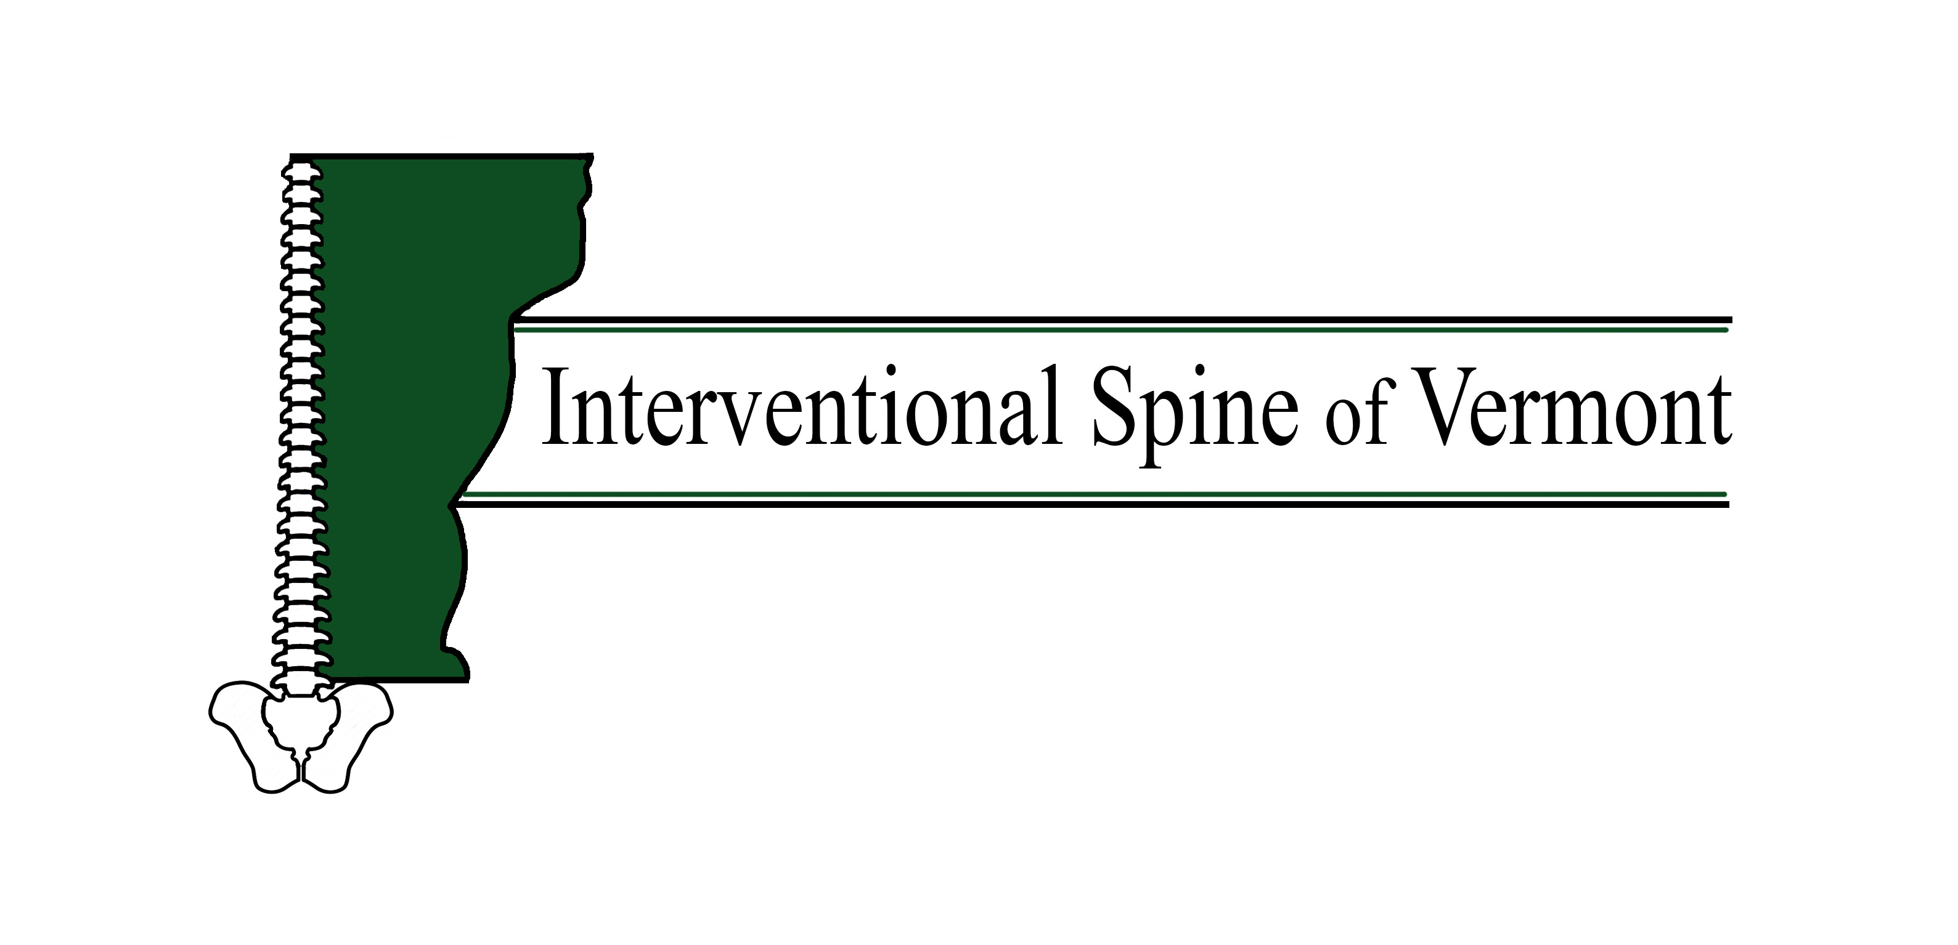
Medial Branch Blocks
What is it? | There are joints in the spine which can, like any joint in our body, show signs of wear and tear and as a result cause pain. The small nerves that innervate these joints are commonly referred to as “medial branches.” Medial branch blocks are injections aimed at blocking the transmission of pain from these nerves. Only a small amount of anesthetic is placed as to not confuse pain relief from the joints from pain relief from other nearby areas (such as the muscles which can carry pain due to tension/spasms). This is a diagnostic block and has to be done twice before the long lasting treatment (the ablation of these nerves) can be performed, per insurance policies. If you are not using insurance to pay for the procedure, you do not need the diagnostic blocks.
Why is it performed? | These blocks are performed when it is believed that neck or back pain is due to arthritis in the facet joints. Arthritis in the joints is one of the main reasons of back and neck pain. Sometimes, steroid is injected with the blocks to decrease inflammation in addition to numbing agent.
How is it done? | When you are in the procedure room, you will be asked to lie on your stomach on an x-ray table. A small needle is used to inject a local anesthetic (numbing medication) in the skin, this may feel like a pinching or burning sensation. This will be done in at least 2 levels (one or both sides of your body depending on where the pain is). At that point, a small needle will be inserted through the numb portion of skin towards the area of interest injured nerve with the help of the x-ray machine. When satisfactory placement of the needle is confirmed, the numbing medicine will be injected (with or without steroid). You will be asked to keep track of your pain and resume normal activities other than driving and keep track of your pain for the 2 hours following the procedure. Please call us within 24 hours to let us know about the results. If your pain relief is less than 80%, an ablation will not follow this procedure as the diagnostic block will be deemed negative (this means that the pain is probably coming from a different source than the facet joints). The needle will be removed and a bandaid will be applied.
How long will it take? | Depends, usually 10-15 minutes
What do I do if I am ill or have to cancel? | Please call the office 24 hours in advance if you are unable to keep your appointment. 802-404-2004 We charge $50 for no shows.
When should I arrive? | Please arrive 15 minutes prior to your appointment.
Can I drive for the procedure? | In general, no. If you cannot bring a driver you will have to call us ahead of time so the provider is aware and can monitor you afterwards
Can I have sedation for the procedure? | No. It is important that you remain fully aware of your typical pain after the procedure so you can keep track of relief.
Can I take my medications? | Please take all your medication except for blood thinners and supplements. Also please stop NSAIDs (including but not limited to ibuprofen, advil, motrin, naproxen) 24 hours prior to your injection
Should I stop my aspirin? | If you take more than 81 mg of aspirin a day, you must stop taking it 5 days prior to your procedure (examples of ASPIRIN‐containing products include but are not limited to: EXCEDRIN, FIORINAL, AND ALKA SELTZER, etc). You can continue aspirin 81 mg if you take it for stroke or heart attack prevention.
Will I receive a pre‐procedure phone call? | You will receive an automated phone call or text (if enabled) from our office 24‐48 hours prior to your procedure. We must have a verbal confirmation from you 24‐48 hours prior to your procedure. Failure to return our call could result in your procedure being rescheduled.
What are side effects of the steriods? | Flushing, higher sugar levels, higher blood pressure, mood swings, problems sleeping, and they can lower your bone density among many side effects
Risks of this procedure include, but are not limited to: | Pain at the injection site for 2-3 days (ice can help)  Reaction to the local anesthetic Please let us know if you have ever had a reaction  Side effects from steroids as above.  Tell us before the procedure if taking blood thinners, have a blood disease that affects clotting, have a bowel obstruction and or have an uncontrolled infection.  Bleeding in the area of the injection due to damage to blood vessels.  Possible, but unlikely side effects are:  -- infection  -- bleeding  -- nerve damage  -- worsened pain  -- no improvement  -- stroke  -- death

